The Little House on the Prairie Handbook

By Justine Zimmerman

A guide to the most famous pioneer TV show in history

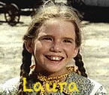

Introduction
This is for Frances, Claudia, Eva, and all my other friends who have to sit next to me and listen to me blabber on and on about this wonderful show called “Little House on the Prairie” without knowing anything about it. This is also for any other unfortunate soul in that position, or even a diehard “Little House” fan who just wants to know even more about the show they already learned so much about. Yes, this handbook is based on the show, not the book (I personally think the show is 10 times better). Also, it might seem strange for you to hear me (a 12 year old girl), talk about how much I love the show that my mother grew up watching. Well, get it out of your head that I only like teenage drama shows like GLEE, GOSSIP GIRL, THE SECRET LIFE, etc, because I don’t like teenage dramas at all, or any kind of dramas for that matter. And I’m not going to stop there. I also like the Beatles, Abba, and Green Day. But lets get back to the point. Basically, I just want you to read the following pages, whether you like “Little House on the Prairie “or not, or whether you’ve even heard of the show or not. JUST READ IT!!!

Charles “Pa” Ingalls-Michael Landon
Michael Landon isn’t just one of the main characters, and the official “star” of the show, he’s also the producer.
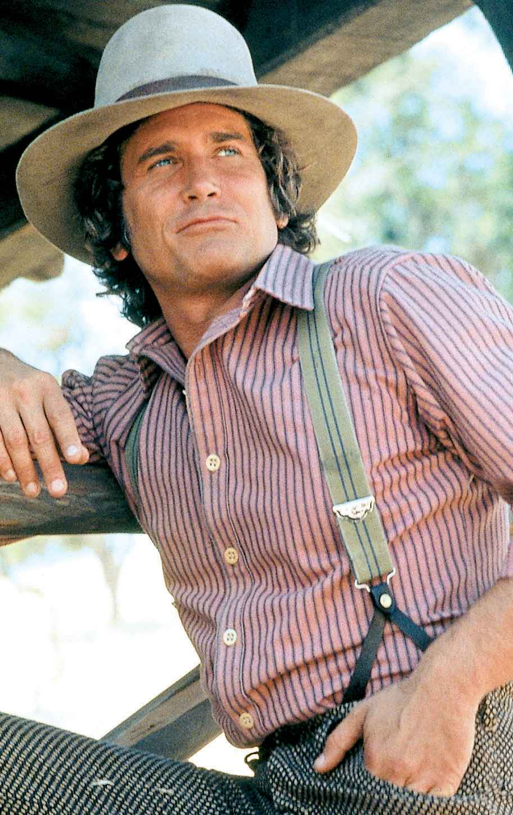

Caroline “Ma” Ingalls-Karen Grassle
Caroline, or “Ma”, as her children call her, is a perfect mother and an even better wife. She is sweet, kind, and always fond of a good laugh.
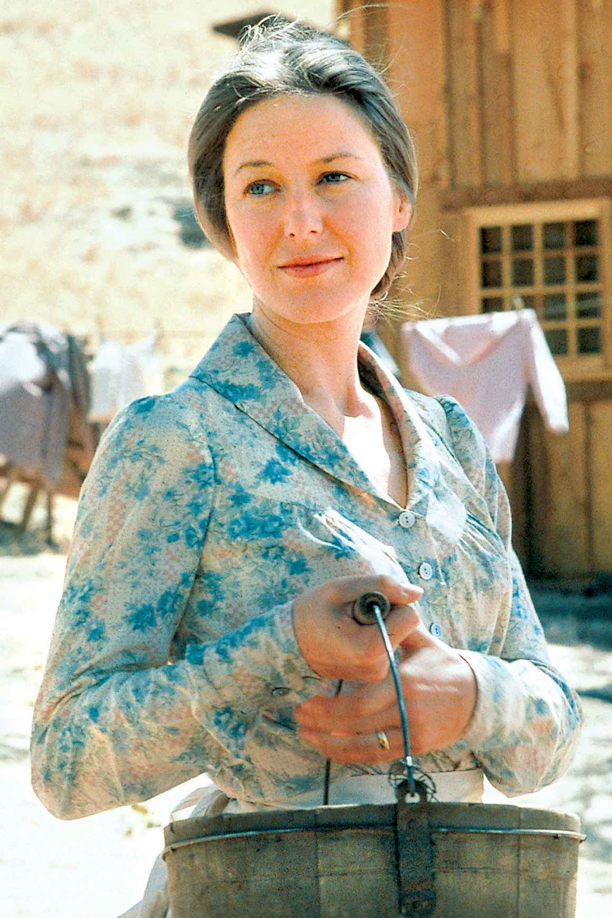
Mary Ingalls-Melissa Sue Anderson
Laura’s older sister, Mary has always had a more mature attitude than rambunctious Laura.
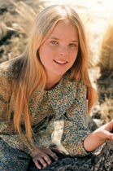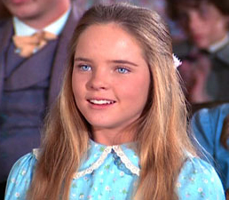
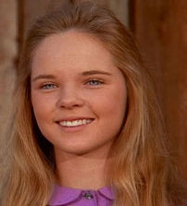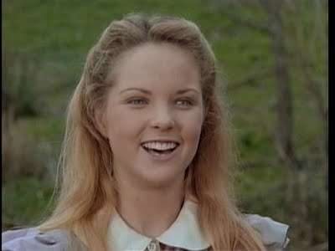
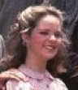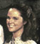

Laura Ingalls-Melissa Gilbert
She is the star of the “Little House” books as well as the TV show.
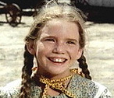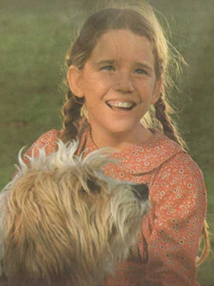

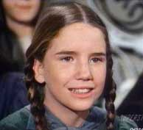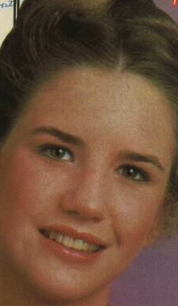
Albert Ingalls-Matthew Laborteau
Albert is the Ingalls’s first adopted child. After running away from an orphanage, Albert lived on the streets, where he met the Ingalls. He is Laura’s partner in crime, and is also one of her best friends.
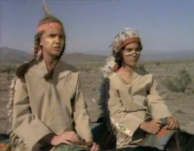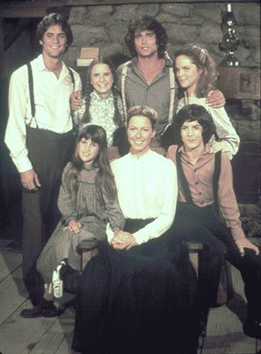
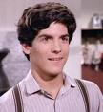
Carrie Ingalls-Lindsey & Sydney Greenbush
Carrie is the third biological Ingalls child, and was the family’s “baby” until the arrival of Grace in the 4th season.
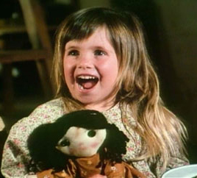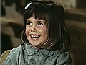
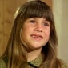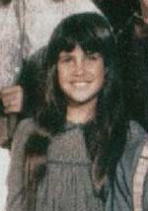

James & Cassandra Cooper/Ingalls-Jason Bateman & Missy Francis
After the Ingalls’s friends die in a wagon accident, Charles and Caroline adopt their two young children.
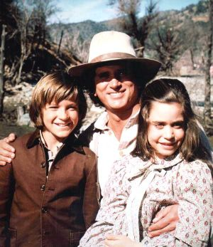

Grace Ingalls-Wendi & Brenda Turnbaugh
The Ingalls youngest biological child, Grace was welcomed into the family in the 4th season, and doesn’t play a big part in the show, as she was still very young.
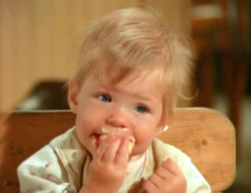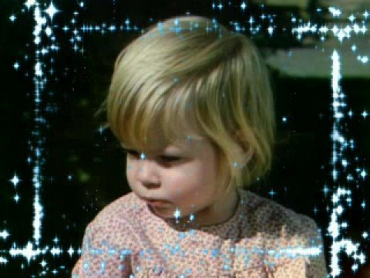
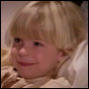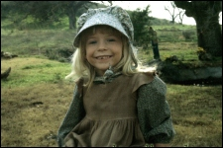

Adam Kendall-Linwood Boomer
Adam is Mary’s husband. They had one miscarriage and one child together, but the child died soon after in a fire. They also founded their own Blind School, to help children who are blind like them.
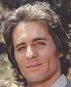

Almanzo Wilder-Dean Butler
When Laura was roughly 18, she married Almanzo Wilder. They had 2 children together, but one died at a young age. They later adopted Almanzo’s niece, Jenny, after the death of her father.
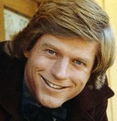

Rose Wilder-Jennifer & Michelle Steffin
Rose is Laura and Almanzo’s first and only surviving child.
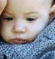

Jack Ingalls
Jack was the Ingalls’s first dog, and was with them during “Little House in the Big Woods”, but sadly, he dies around the 4th season.
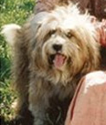
&
Bandit Ingalls
Bandit was a stray dog who happened to cross Charles’s way in the city. He comes in around the same time Jack dies.
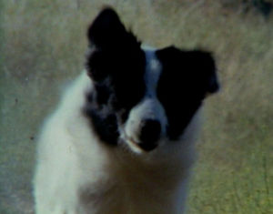
Lars Hansen-Karl Swenson
Lars is one of Walnut Grove’s founders, and also runs Hansen Lumber Co. He is Charles’s employer, and also a very good friend of his.
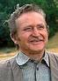

Views from the “Walnut Grove” set
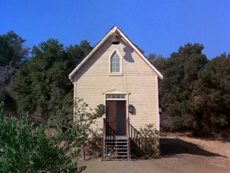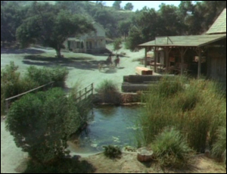

Dr. Baker-Kevin Hagen
Dr. Baker is the town’s all around doctor/vet, and a very good friend of the Ingalls family.
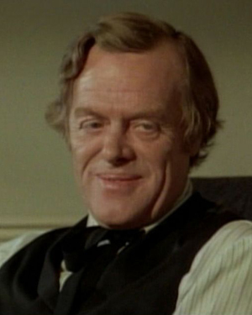
&
Reverend Alden-Dabbs Greer
Rev. Alden is the town’s preacher, and runs the Sunday sermons.
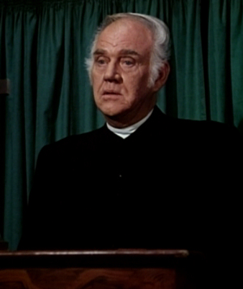
Eva Beatle
Ms. Beatle was the schoolteacher until season 4, when Alice Garvey replaced her. She was always kind and loving towards her many students, and was particularly fond of Mary and Laura.
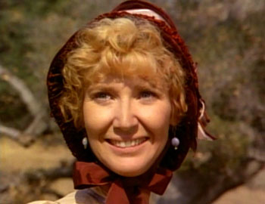

Eliza Jane Wilder-Lucy Lee Flippin
Eliza Jane Wilder was very important in the “Laura-Alamnzo” relationship because she was the one who started it as a new teacher arriving in Walnut Grove with her young brother, Almanzo. She was the teacher who replaced Mrs. Garvey.
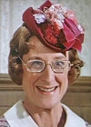
Nels & Harriet Oleson-Richard Bull & Katherine MacGregor
Nels and Harriet are the parents of the parents of Nellie and Willie. The Olesons own the town mercantile. Nels is very
laid-back, so Harriet takes charge of things more often than not.
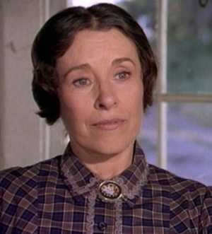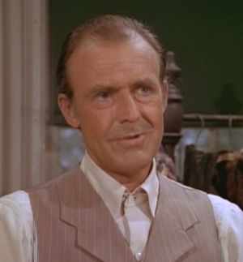

Nellie Oleson-Allisonn Arngrim
Nellie is the oldest Oleson child, and with Willie and her mother at her complete disposition, she is quite the snob. Her favorite hobby is bullying Laura.
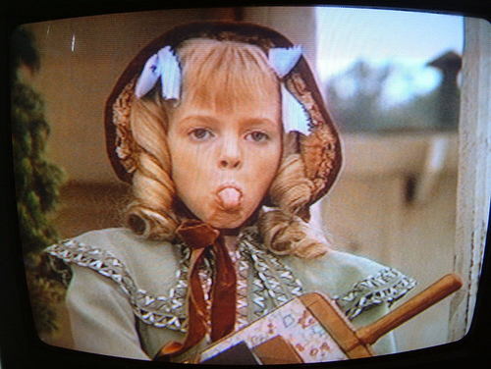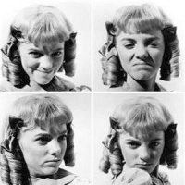
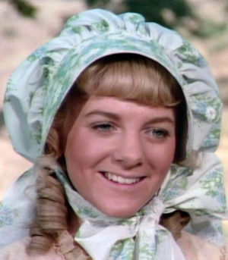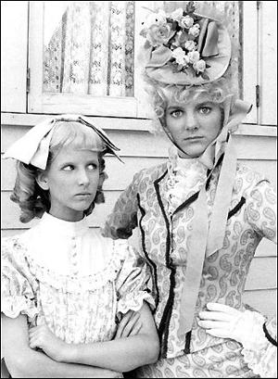

Willie Oleson-Jonathan Gilbert
Willie is his older sister Nellie’s sidekick, and helps her make the most out of bullying. He is also one of the school’s worst students, and is quite lazy.
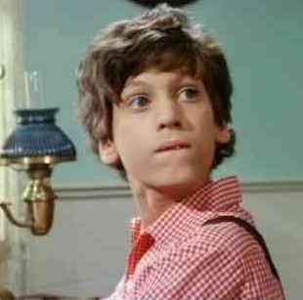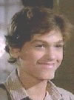

Nancy Oleson-Alison Balsom
After Nellie gets married and moves out, Harriet adopts another snobby little blond, Nancy.
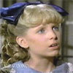
&
Jenny Wilder-Shannen Doherty
When Almanzo’s brother dies, he and Laura take in their young niece, Jenny.
No pictures found
Jonathan Garvey-Merlin Olsen
The Garveys arrive in season 5, and quickly become the Ingalls friends. They stay close throughout the rest of the series, although Jonathan and his son move away after the death of Alice, Jonathan’s wife.
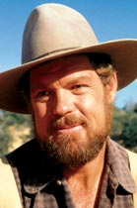

Alice Garvey-Hersha Parady
Alice Garvey is very friendly with Mrs. Ingalls, and becomes the Liberty School teacher (Mrs. Ingalls’s idea) when the Ingalls, Garveys and Olesons move to Winetka. Sadly, both Mrs. Garvey and Mary Ingall’s baby die in a fire.
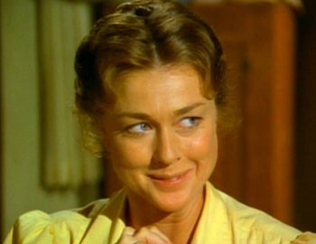

Andy Garvey-Patrick Laborteau
Andy Garvey was Albert Ingalls’s devoted friend throughout the fifth season, and Laura, Albert and him where all partners in crime. Andy was quite sad to leave Walnut Grove in season 6.
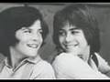

Isaiah Edwards-Victor French
Mr. Edwards met the Ingalls before they moved to Walnut Grove, and faithfully re-encountered them around season 2. He later married Grace Snider, and adopted John Jr, Carl and Alicia Sanderson/Edwards.

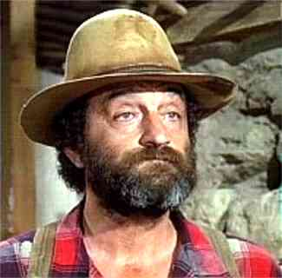

The Edwards Family
Quite a while after settling down in Walnut Grove, Isaiah Edwards married Grace Snider and adopted John Jr, Carl and Alicia Sanderson/Edwards, three siblings who had recently lost their parents, the Sandersons.
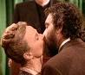
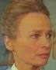
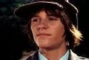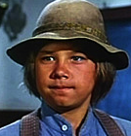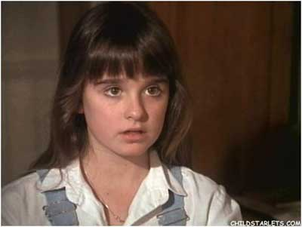
Then and Now!
Matthew Laborteau:
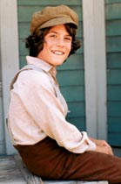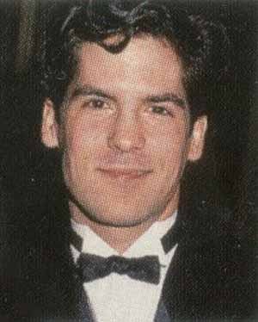
Melissa Gilbert:
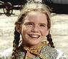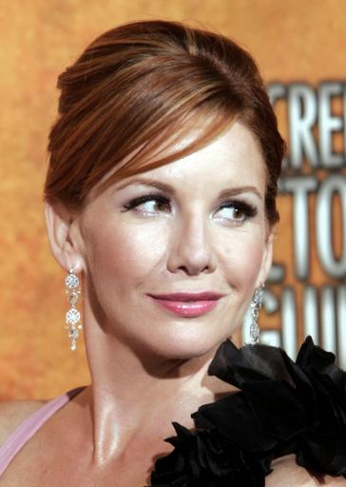
Melissa Sue Anderson:
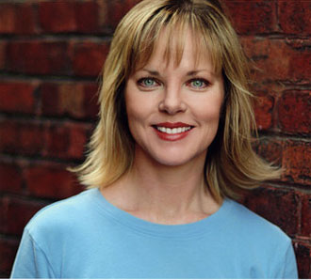
Sydney & Lindsey Greenbush:
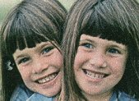
Brenda & Wendi Turnbaugh:
